Prompt:
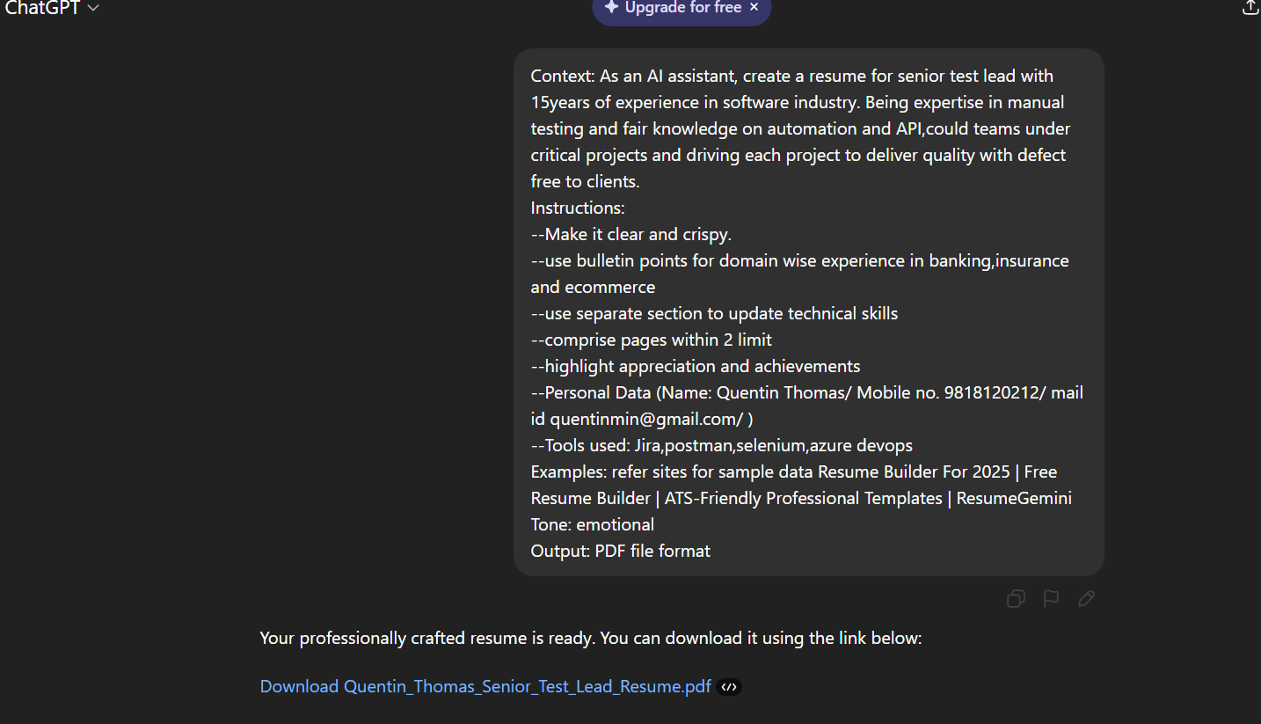Chatgpt results as pdf:
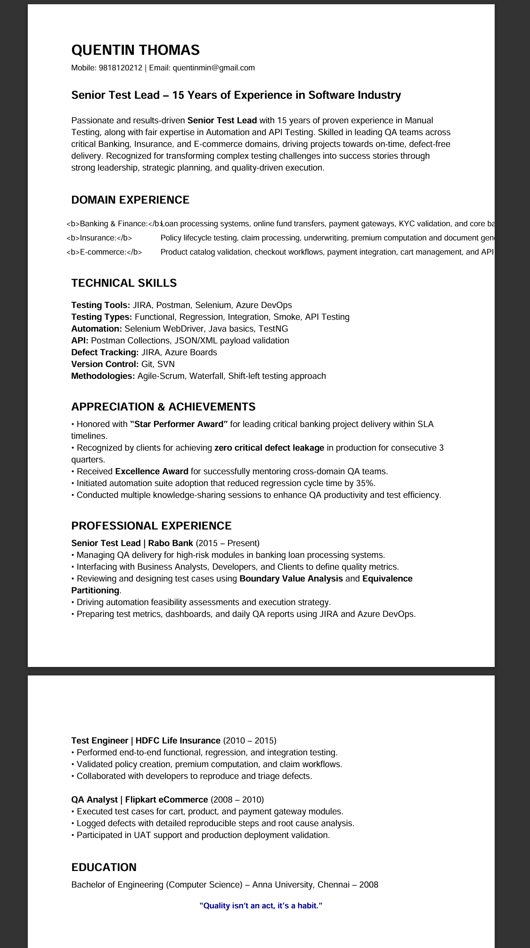

Prompt 2 for corrections in pdf: domain experience not in readable format. Correct and update resume in pdf
